# Cub Car Timer

## Introduction:

Overview – The Cub Car timer is a project designed to run and manage cub car (pinewood derby) races to help run them in a fair and fun fashion.

### Goals

1. Be able to build timers which can run in a number of different configurations for a price of < $75.00 per timer. (Not including optional RFID tags)
2. Provide enough instructions and directions that a technically savvy person can build their own timer with
3. Allow for multiple timers to work alongside each other at a single rally. (1 timer per track)
4. Have solution that can be retrofitted onto a track is less than 2 hours of time and which is minimally invasive to the tracks. (As many tracks are practically heritage pieces)
5. Have supports for a wide variety of configurations and options so that groups can tailor the solution to their particular needs.
6. Support tracks from 2-8 lanes (Goal Not Met)
7. Develop everything opensource and publicly available so other groups can build on the solution.
8. Generate excitement about the project and get a few other groups to collaborate on the builds / programming etc.
9. Future versions of this project will attempt to redevelop the project to run on an Arduino box which is considerably cheaper than a PI, but which doesn’t have the same processing capacity.

## Cub Car Rallies - History

Having been involved with CubCars over the past few years I have noticed that CubCar rallies tend to run one of two ways:

1. Kids are given a piece of paper and run around from track to track racing whomever they feel they can beat with their car. The count of wins and losses are totaled and the most number of “wins” move onto the next round. The problem with this approach is that some cars which “may” have made it into the later rounds may not have made it into those later rounds as they were eliminated by kids who figured out how to “game” the races and would only challenge cars they thought they could win against. The pro of this type of approach is that it allows for multiple tracks to be running concurrently, (but only 2 cars race at a time).

If multiple tracks are used then kids quickly figure out which track their car runs ‘best’ on and try to race on that track as much as possible.

OR

1. All the racers are entered into spreadsheets which do pairings of racers which then determines who races who when. Often this means that only a single track is used to support and manage the races.

Although this timer can be used with this approach it can also be used in a very different way which leverages the best parts of both afore mentioned solutions.

As this solution incorporates both RFID tags and a database it allows for a very different approach to running races. Arguably a more fair approach. It is not about placing, it is about time.

1. Kids can run as many races as they would like against as many cars that they would like, so long as they run at least 5 (variable #) races on each track.
2. The cumulative time for the 5 fastest races on each track are totaled and ranked by shortest time.
   1. If multiple tracks are used then the cumulative time across each track is done and a combined ranking is done to determine the winner.

## Solution Overview

The following is the layout of how the various bits and pieces of the solution can be assembled together:

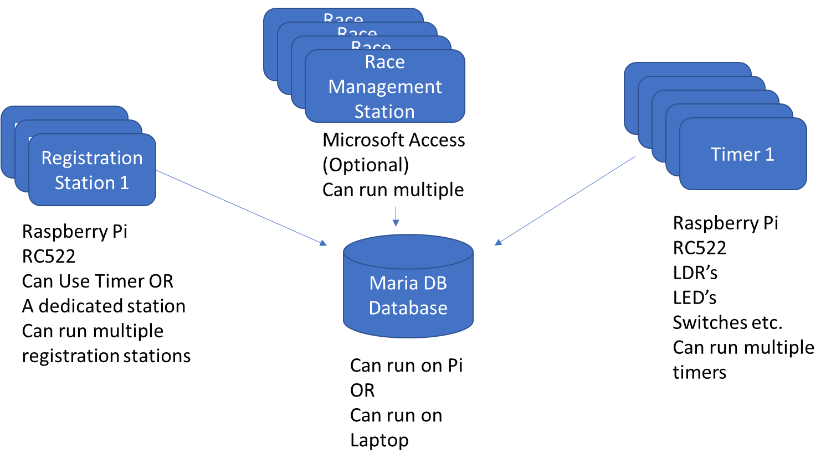

**Registration Station:** Raspberry Pi with an RFID pad on it which registers in the database the Car Name and the Name of the Racer and ties it the RFID tag on the car. (This can be run on the timer in between races) If you have a dedicated registration station you can use a pi zero as it is not a particularly demanding application. Note: If you are running a pi Zero you cant put MariaDB on it. (Not enough horsepower) Multiple registration stations can all be running at the same time.

**Timer:** This is the main unit that runs all the races and is the heart of everything. This runs on a raspberry pi.

**Race Management Station (MS-Access Database)**: This is an optional piece of the solution but it allows for a whole bunch of additional information to be collected and managed and supports running all the reporting for the solution. (As Maria DB itself does not have a GUI) It has a bunch of incomplete features in it. In future iterations of the solution this would get replaced with a web app. (Likely PHP, running on NGINX, which can also be hosted on a pi) today this must run on a laptop that has a Microsoft Access license on it. All of the tables in the MS-Access database are linked tables to the MariaDB database and do not store anything locally in MS-Access. Because the tables are linked you can have multiple race management stations running although likely at most all you will need is 1.

**MariaDB:** This is where all the information on the races and racer information is stored. Although there are a number of tables in the database the only two that matter for running and managing races are *racerinfo* and *raceresults.* The *raceresults* table is heavily denomalized so that is can be exported into Excel and have all the information in it to support analysis and further reporting.

The MariaDB can be hosted on the timer, can be on a dedicated raspberry pi or can run on a laptop. Although the solution can run without the database or the RFID pad. (If you use the RFID pad then you need the database)

## Raspberry PI

The timer was developed using a Raspberry PI v3 with a standard Raspbian Stretch install on it. For those who are not familiar a Raspberry PI is a credit card sized computer that can be purchased for < $50.00 from a variety of different places. (Amazon, Ali Express, Banggood etc.)

A raspberry utilizes an SD Card for storage and to house its operating system. You will want a good quality 16GB or greater class 10 card. (Type used in higher end cameras) You can get one for < $10 off of amazon.

The project likely could run on a V2 of a Pi, however I don’t have one that I can validate / test on, it runs very well on either a V3 or V4 pi.

A raspberry PI has a series of pins on the top of the board (40 of them) called the GPIO (General Purpose Input / Output) which all the bits and pieces of the track will connect too.

I will not attempt to explain how to initially setup the Raspberry PI as there are lots of Youtube videos on this already available.

Once you do have the PI setup you will want to turn on a few features.

SPI interface – Needed for either the LED Matrix or the RFID Card

SSH services – needed so you can remotely transfer files on and off of the PI

VNC services – If you want to utilize remote keyboard / video / mouse for your PI.

This project can run Headless (No keyboard, Mouse, Monitor) plugged directly into the raspberry PI, but you would likely want to use VNC services if you do run headless.

## Useful software

The following table outlines some software you may want to install on your laptop to help with this solution, except for Microsoft Access all the tools listed below are free.

|  |  |
| --- | --- |
| **Item** | **Purpose** |
| Filezilla | Utility for transferring files to / from your PI |
| VNC Viewer | Utility to provide remote keyboard / video / mouse |
| Notepad ++ | Useful for editing / reading / updating code and configuration files. NOTE: On certain files regular Notepad will corrupt python and config files! |
| HeidiSQL | Tool for managing MariaDB databases. (Installed by default when some MariaDB versions are installed) |
| MariaDB | This is the open source Database where all the racer information and race results are all stored. Maria DB can be installed either directly on the PI or on a separate laptop. (Laptop preferred if using more than 1 timer) |
| MariaDB ODBC Connector (32 or 64 bit) | Depending on what version of MS-Access you install you will need to install either the 32 bit or the 64 bit ODBC connector. This does not install with Maria DB by default and is a separate download and install. |
| MS-Access | Anything newer the MS-Access 2014 should work to be able to run the race-insights application. |

## Cases and Enclosures

You do not need to 3D print out the parts as really any enclosure can work.

The designs for the cases and enclosures are all posted up on Thingiverse if you want to 3D print out pre-designed boxes for your timer. You will need a full sized 3D printer to be able to print these pieces.

NOTE: I am not an engineer, designer, heavy CAD user so these designs are not “perfect” holes may be slightly misaligned etc.

The cases and enclosures posted on Thingiverse are for tracks with 3 lanes, however they can be readily reworked to support additional lanes.

The RFID pad prints out in 3 pieces:

1. Box
2. Face Plate
3. RC522 H bracket

The Main Timer prints out in 6 pieces

1. Box for PI
   1. (Both V3 and V4 designs are posted)
2. Back Plate
3. Main enclosure
4. Light bank
   1. As the number of LED’s required for your track’s optimal performance may vary I made this piece replaceable
5. Relay holder (Optional)
6. Face Plate

If you do decide to build your own enclosure, a few things to keep in mind (Hard won advice).

1. You will want ready access to all the ports and connectors on the PI, you may want to even install it on the outside of your enclosure.
2. SD cards can be brittle. I made access to SDCard too difficult in earlier designs and broke a few attempting to remove and put back in.
3. You will have a lot of cable and wires to have to manage, you will want to think a bit about cable management.
4. Put your “place” LED’s at the top of the timer where they can be seen from all angles. Our first version only had indicators on the front panel that could only be seen from one side.
5. You may have to open the timer a few times to troubleshoot / tinker / check wires etc. Make sure you can access the inner bits and pieces without having to disassemble everything to get access.

All the sensors are directly connected via the GPIO port. The program and controller is setup for 3 tracks, but could be expanded for 4 tracks. (Code would need help to expand to additional tracks)

The following is the circuit diagram and parts list.

|  |  |  |
| --- | --- | --- |
| 15 - High Power LED’s | 3 - 10K Light Dependent Resisters | 12 – 300 OHM Resisters |
| 1 – Momentary Push Button | 1 – Raspberry PI 3.0 | 1 - 40 PIN Header (Optional) |
| Strip Board or PCB | 3 - DB 9 Connector | 1 - 2 wire Extension Wire (Length of Track) (Speaker Wire) |
| 1 – RCA (track button Cable) | 1 – Raspberry PI Touch Screen (Optional) | 1 – MAX7219 LED Array (Optional) |
| 1 – RC522 RFID Reader (Optional) | 1 – 5 V PI compatible Relay board (Optional) | 1 - RS232 9 wire M-F cables (Length of Track) |
|  |  |  |

NOTE: During testing you can use Pushbutton Switches instead of LDR’s if you don’t have any LDR’s yet.

**Electronics**

This circuit is the basic “Heart” of the project. The PINS that the LED’s and LDR’s are on are customizable depending on your needs. The wiring diagram does not show the MAX7219 or the RC522 RFID reader.

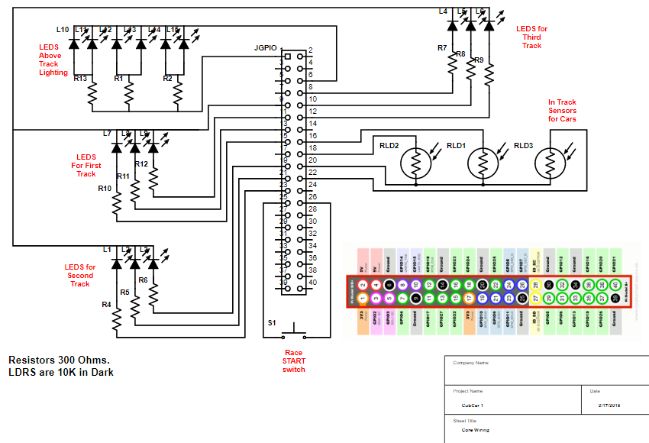

Note: The GPIO pins that the LEDS, LDR’s and switch are on are all configurable. Using the Legend you can use ANY of the PINS that are the same colour for the same purpose if you have conflicts with new devices you want to introduce.

Here is the latest wiring list for version 3 of the project.

|  |  |  |  |  |  |  |  |  |  |  |
| --- | --- | --- | --- | --- | --- | --- | --- | --- | --- | --- |
| **Pi PINS** | **Usage** | **RFID PAD** | **RELAY BOARD (Future)** | **BUTTONS** | **TRACK LIGHTS** | **BANK LIGHTS** | **Track Switch** | **LDR** | **MAX 7219** | **Notes2** |
|  |  | **7** | **3** | **3** | **2** | **10** | **2** | **4** | **5** |  |
| 1 | 3.3 V |  |  |  | 3.3V |  |  |  |  |  |
| 2 | 5 V |  | 5V |  |  |  |  |  | 5V |  |
| 3 | GPIO02 |  |  |  |  | GPIO02 |  |  |  |  |
| 4 | 5V |  |  |  |  |  |  |  |  |  |
| 5 | GPIO03 |  |  |  |  | GPIO03 |  |  |  |  |
| 6 | Ground |  |  |  | GND |  |  |  | GND |  |
| 7 | GPIO04 |  |  |  |  | GPIO04 |  |  |  |  |
| 8 | GPIO14 |  |  |  |  | GPIO14 |  |  |  |  |
| 9 | GROUND |  |  |  |  |  |  |  |  |  |
| 10 | GPIO15 |  |  |  |  | GPIO15 |  |  |  |  |
| 11 | GPIO17 |  |  |  |  | GPIO17 |  |  |  |  |
| 12 | GPIO18 |  |  |  |  | GPIO18 |  |  |  |  |
| 13 | GPIO27 |  |  |  |  | GPIO27 |  |  |  |  |
| 14 | GROUND |  |  |  |  |  |  |  |  |  |
| 15 | GPIO22 |  |  |  |  | GPIO22 |  |  |  |  |
| 16 | GPIO23 |  |  |  |  |  |  | GPIO23 |  |  |
| 17 | 3.3V | 3.3V |  |  |  |  |  |  |  |  |
| 18 | GPIO24 |  |  |  |  |  |  | GPIO24 |  |  |
| 19 | GPIO10 | GPIO10 |  |  |  |  |  |  | GPIO10 | Investigate |
| 20 | GROUND | GND |  | GND |  |  |  | GND |  |  |
| 21 | GPIO09 | GPIO09 |  |  |  |  |  |  |  |  |
| 22 | GPIO25 | GPIO25 |  |  |  |  |  |  |  |  |
| 23 | GPIO11 | GPIO11 |  |  |  |  |  |  | GPIO11 | Investigate |
| 24 | GPIO08 | GPIO08 |  |  |  |  |  |  | GPIO08 | Investigate |
| 25 | GROUND |  |  |  |  |  | GND |  |  |  |
| 26 | GPIO07 |  |  |  |  |  | GPIO07 |  |  |  |
| 27 | ID_SD |  |  |  |  |  |  |  |  |  |
| 28 | ID_SC |  |  |  |  |  |  |  |  |  |
| 29 | GPIO05 |  |  | GPIO05 |  |  |  |  |  |  |
| 30 | GROUND |  |  |  |  |  |  |  |  |  |
| 31 | GPIO06 |  |  |  |  |  |  | GPIO06 |  |  |
| 32 | GPIO012 |  |  |  |  |  |  |  |  |  |
| 33 | GPIO13 |  |  | GPIO06 |  |  |  |  |  |  |
| 34 | GROUND |  |  |  |  | GND |  |  |  |  |
| 35 | GPIO19 |  |  |  |  |  |  |  |  |  |
| 36 | GPIO16 |  |  |  |  |  |  |  |  |  |
| 37 | GPIO26 |  |  |  |  |  |  |  |  |  |
| 38 | GPIO20 |  |  |  |  |  |  |  |  |  |
| 39 | GROUND |  | GND |  |  |  |  |  |  |  |
| 40 | GPIO21 |  | GPIO21 |  |  |  |  |  |  |  |

Note: you cannot have both the RFID PAD and the MAX LED matrix at the same time as they conflict with wiring and software. (Supposedly SPI supports two devices on the PI3, but I haven’t been able to make that work)

The following is the external wiring for the first generation of the solution. (Screen, Sensors, Remote start Button)

Not shown on the diagram are the wirings for the internal LED boards, LED Matrix, RFID PAD or Relay.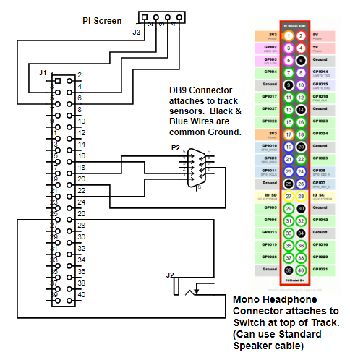

**Internal Wiring**

On the first version of the project I built small PCB’s for the LED’s and the Resistors, and put header pins on all the boards. These took far too long to build. For the second generation I built 1 PCB board. For the third generation I just soldered resistors directly to the LED legs and cut down the amount of time for assembly.



There are a LOT of wires to deal with and manage so you may want to build a colour legend to help keep things straight. For example here is how I wired all the DB9 connectors.

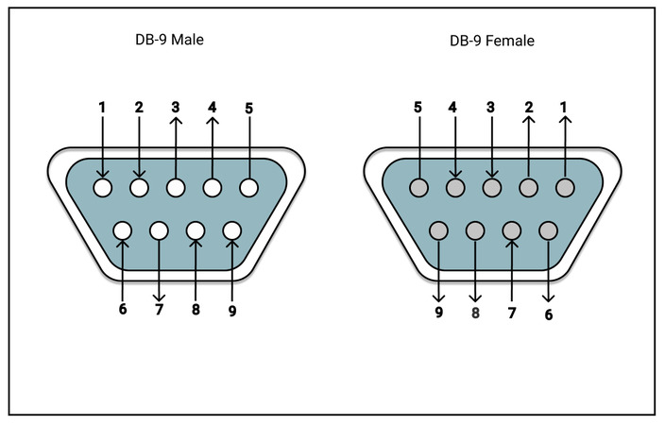

|  |  |
| --- | --- |
| **DB9** | **Diagram Colour** |
| 1 | Purple |
| 2 | Green |
| 3 | Orange |
| 4 | Brown |
| 5 | Black |
| 6 | White |
| 7 | Blue |
| 8 | Yellow |
| 9 | Red |

**MAX 7219**

Adding a Max7219 Matrix:

|  |  |  |  |  |
| --- | --- | --- | --- | --- |
| Board Pin | Name | Remarks | RPi Pin | RPi Function |
| 1 | VCC | +5V Power | 2 | 5V0 |
| 2 | GND | Ground | 6 | GND |
| 3 | DIN | Data In | 19 | GPIO 10 (MOSI) |
| 4 | CS | Chip Select | 24 | GPIO 8 (SPI CE0) |
| 5 | CLK | Clock | 23 | GPIO 11 (SPI CLK) |

Unfortunately the Max7219 matrix conflicts with both the integrated screen and the LED Bank, so for the 2nd generation I did not put in a touch screen but used an external monitor.

The Max7219 and the Pi Screen share a ground PIN (PIN 6)

Here is the code you need to run to install the MAX libraries for the LED Matrix.

sudo -H pip install --upgrade --ignore-installed pip setuptools

sudo usermod -a -G spi,gpio pi

sudo apt install build-essential python3-dev python3-pip libfreetype6-dev libjpeg-dev libopenjp2-7 libtiff5

sudo -H pip3 install --upgrade luma.led_matrix

**LDR’s – (Light Detecting Resistors)**

I originally bought a 20 pack of assorted LDR’s from amazon and discovered that only a few of them actually work on the raspberry PI for this purpose. (Some were too sensitive, some needed way too much light to dark to actually trigger, some I could never get to trigger.) You can either buy a big assortment pack and trial and error your way through or buy one of the two types listed below.

Gl5549

Gl5537

(Note: Even if you buy one of these two types you will want to test them prior to installation as they have a lot of variability in their functionality)

**RF ID PAD**

To be able to install the RF-ID PAD you need to execute the following on your raspberry pi:

sudo apt-get update

sudo apt-get upgrade

sudo apt-get install python3-dev python3-pip

sudo pip3 install spidev

sudo pip3 install mfrc522

|  |  |  |  |
| --- | --- | --- | --- |
| **RS522 Header** | **Diagram Colour** | **PI Header** | **Notes** |
| 3.3 V | Red | 17 | 3.3V |
| RST | Brown | 22 | GPIO25 |
| GND | Black | 20 | Ground |
| IRQ |  |  | Not Connected |
| MISO | White | 21 | GPIO9 |
| MOSI | Green | 19 | GPIO10 |
| SCK | Maroon | 23 | GPIO11 |
| SDA | Blue | 24 | GPI08 |

**Relay Board**

The relay board is a planned future enhancement whereby external light tree can get triggered to countdown the race. This runs on a completely different circuit. It is a 3 wire relay board.

|  |  |  |  |
| --- | --- | --- | --- |
| **Relay Board** | **Diagram Colour** | **PI Header** | **Notes** |
| 5V+ | White | 2 | 5V |
| GND- | Black | 9 | Ground |
| SIG | Grey | 16 | GPIO23 |

**MariaDB**

The third iteration of the program (under development) intents to use MariaDB to store racer information, car information and race results. The MariaDB can sit on either the raspberry PI or can run on a laptop. By using a database to store the information it allows for several timers to all run on separate tracks and to aggregate results in some really interesting ways.

You can find instructions on how to download and install MariaDB on the web so I wont cover that.

Note you will need to install the mySQL connector to make this work.

sudo pip3 install mysql-connector-python

A note about MariaDB and ROOT.

You cannot use root if you want to access the database remotely, you will need to create another user and grant it all the necessary privileges for that to function.

create user cubcaradmin identified by 'XXXX';

grant all privileges on *.* to 'cubcaradmin' ;

If you have MariaDB installed on a raspberry pi and you want to access it remotely you will also have to edit:

/etc/mysql/mariadb.conf.d/50-server.cnf

Change bind address to 0.0.0.0 instead of 127.0.0.1

If you are installing Maria DB on a laptop it will automatically also install HeidiSQL which is a very handy utility for managing the database and writing queries etc.

**Microsoft Access Application**

The Microsoft Access application is an optional piece that gives a much better visual layer on top of the database. In the future I will switch this over to running flask against a web server, but since I know access fairly well this was the fastest way to get things done.

In order to have the Microsoft Access application connect to Maria DB you will also need to install and configure the MariaDB ODBC Connector.

Depending on whether you have installed the 32 bit or 64 bit version of MS-Access you will need to pick the right version of the ODBC driver to install. (Spent a lot of time figuring out that issue.

If MS-Access is on the same computer as the MariaDB database you would configure the database as IP 127.0.0.1 🡨 Which is localhost.

When naming the ODBC connection name it: **CubCar LocalHost 64** otherwise you will need to reconnect all tables in the MS-Access Database.

**The Program**

I wrote the project originally in Python2, but upgraded to Python3 as part of the 3rd iteration.

Because I have been through several different versions and configurations of the timers all of the core settings for the timer are stored in an .ini file (Older versions called it settings.ini, after version 3 it is called RMSettings.ini).

Within this file all the core attributes of the project can be changed and adusted. The file is broken into several sections:

* Settings – This is information on how things are wired, debounce time for switches, Unit # etc.
* Dbase – These are all the settings for the database
* Races – This is information on fastest racer, what heat, etc.. (Mostly obsolete now that database is in place)

The GPIO’s identified in the settings file are the physical PIN numbers, not the GPIO names.

[Settings]

GPIO_relay_1 = 16 ## PIN for optional external relay

GPIO_track_switch = 29 ## PIN for switch at the top of the track

track_switch_bounce_time = 600 ## Debounce time for Switch at top of track

GPIO_car_select_switch = 31 ## PIN for optional switch in RFID PAD

car_select_bounce_time = 600 ## debounce for car select switch (may need to tune)

GPIO_pad_switch = 33 ## PIN for secondary switch on RFID PAD (Future)

pad_switch_bounce_time = 600 ## debounce for secondary switch on RFID PAD (Future)

max_race_time = 12 ## How long can a race be, will want to adjust

min_race_time = 1 ## How short can a race be. (DO NOT SET TO ZERO)

GPIO_ldr_lane_1 = 16 ## PIN for Light Resistor Track #1

GPIO_ldr_lane_2 = 22 ## PIN for Light Resistor Track #2

GPIO_ldr_lane_3 = 18 ## PIN for Light Resistor Track #3

leds = 12,10,8,15,13,11,21,5,3 ## PINs for the LED’s on the light bank

unit = 1 ## What Unit # is this, Change this if multiple times

matrix_yn = N ## Using Max 7219 Y/N?

[dbase]

host=192.168.100.251 ## What is the IP of the computer where database is?

user=cubcaradmin ## What is the name of the account to access DB

passwd=XXXXX ## Password for the database

database=attendancesystem ## Name of the database

[Races] ## Information that updates constantly

gfastestlane = 2 ## what lanes was fastest

gfastesttime = 2.8618221283 ## what was the fastest time

gfastestracecounter = 6 ## How many races run today

race_counter = 0 ## What race # are we at

heat = 1 ## What heat

In future will be changing the program to prompt for database password on load (better security practice)

When starting a new set of races reset all the values in that section to 0 before starting the program.

**Starting the program:**

The program will update both to a terminal screen as well as to a GUI.

The screen and raspberry PI both have separate power supplies, the screen needs to be plugged in first then the PI.

At this point the program does not autostart so it needs to be manually started.

1. Open up Terminal Window
2. Go into cubCar directory - “***cd cubCar***”
3. List directory “***ls***”
4. Start the program “***sudo python3 RaceManager.py***”

**Exiting out of the program**:

Because the program waits for events to happen on the GPIO to exit properly out of the program you need to do the following:

1. In GUI press on the X in the top corner. (Wont look like you have done anything)
2. Swap to the terminal window.
3. Hit CTRL-X
4. Depress and release the remote trigger button

Program should end and cleanup the state of all of the LED’s etc. (Note: If you don’t exit out of the program properly you run the risk that the GPIO will be left in an inconsistent state and future programs will behave erratically.)

**Troubleshooting**:

Three main issues exist in the program today:

1. If room is too bright then ambient light will not allow for the light sensors to trigger. The track works best in a semi dark space. (Move away from windows etc.)
2. The GUI framework consumes 100% of CPU for the first few minutes it runs. You will want to wait a few minutes before running first races which “count”
3. GUI may become unresponsive. Unknown what the root cause is. Restart the program to correct.
4. Cars run down track, but race does not “start” – Most likely cause is that start button was triggered improperly. For future race need to wait longer between pressing the start button and releasing it. (See section on start button)

**Running a Race:**

* On the GUI the Red circle means that you can prep the track and load cars. Do not load cars if the GUI showing a green circle. (That means previous race has not yet finished)
  + Flip up the track start which will depress the race start button.
  + Put first car on RFID pad, and lights over 1st track bank will light up.
  + Hit button 1 on RFID pad
  + Put next car on RFID pad and light over next track will light up
  + Hit button 1 on RFID pad
  + Repeat for all the cars.
  + Wait a few seconds before releasing cars down the track.
  + Circle turns green indicating that race has started
  + Lights will quickly flash on controller when race has started successfully.
  + Finishing indicators will show which cars completed in 1st, 2nd and 3rd.
* If only 2 cars are racing or car(s) derail then race will automatically end after 20 seconds. (Circle turns Red indicating race is finished.)

**Understanding the Start Switch**.

On the track you will want to source a button something like this which is closed when cars are being loaded and opens when the cars are released. You will want to rig the track so that you don’t jiggle switch too much or you wont get reliable track start and stops.

The program will stop and wait for 2 events on the start button at least 1 second apart. (Button Push Event, followed by a button release event).

In the event of ongoing issues with the reset switch not functioning properly the following changes can be made.

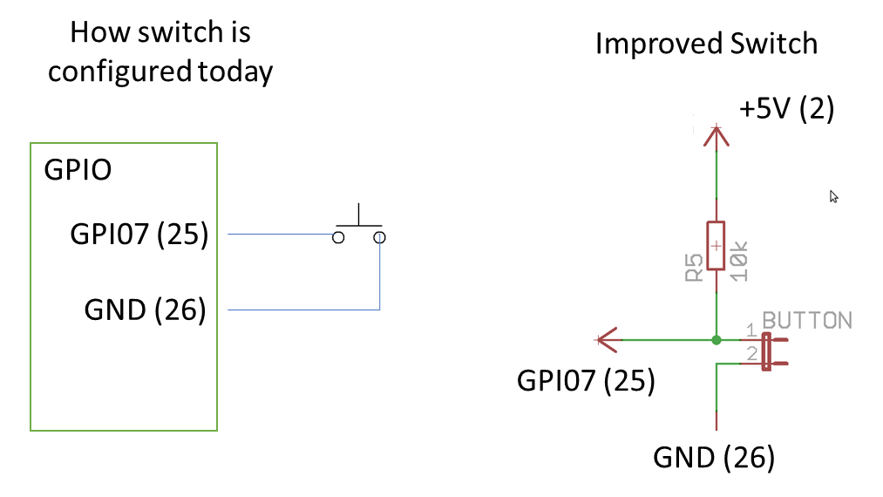

Future Enhancements:

The programming itself is horrible as it is a cobbling together of a few different programs without a lot of time spent on optimization. (No Consistency with Naming Conventions, inefficient code etc.)

For future: Use of threading and callbacks to make GUI more responsive.

For future want to change the RFID pad to use I2C instead of SPI as it allows for longer cables to the RFID PAD. (50’ is really pushing it with RFID pad)

May want to look at LED multiplexing to allow for much more interesting visuals.

GUI is horrible and needs complete redesign.

`

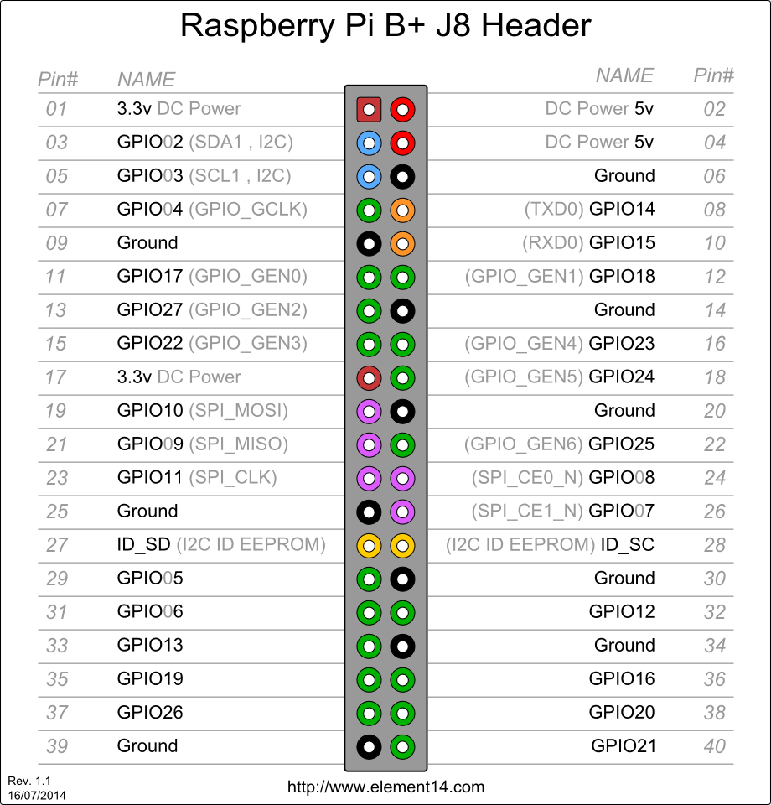

If using a CAT5 port instead of RS232 (8 pins vs 9, so only supports 1 button on the pad)

|  |  |
| --- | --- |
| Brown | Red |
| Brown White | Brown |
| Green | Black |
| Green White | White |
| White Blue | Green |
| Blue | maroon |
| White Orange | Blue |
| Orange | Yellow |
|  |  |